**BIT302**

**Software Engineering Assignment 1**

**Project Proposal**



Project Title:

Information System for MHS

Prepared By:

Leader: I Kadek Bagus Paradhita Utama ([E1700866/bagusparadhita@gmail.com](mailto:E1700866/bagusparadhita@gmail.com))

Member: I Nengah Wahyudi Setiawan ([E1700868/nengahwahyudi90@gmail.com](mailto:E1700868/nengahwahyudi90@gmail.com))

**Table of Contents**

**Project Proposal2**

Introduction 2

Project Background2

Project Aims 2

Project Objectives3

Project Scope3

Project Schedule 3

Prototyping Methodology 3

Work Breakdown Structure3

Milestones/Deliverable 4

Gantt Chart 5

Technical Description7

Development Platform7

Demonstration Platform8

Risk Management Plan9

**Introduction**

Big cities do offer a variety of business or work opportunities and special tourist attractions to explore. Starting from shopping centers, amusement parks, education centers and rows of office buildings with job vacancies offered, all can be found in big cities easily. However, all this luxury is also accompanied by expensive living costs, especially in the residential sector, which will certainly be a big problem for young people who have to live independently, such as students, recent graduates and job seekers.

Proposals to overcome the housing crisis in big cities have actually been proposed in the United States, Canada and Hong Kong in a variety of different ways. Meanwhile, young people in Kuala Lumpur also face a similar problem. Therefore, the Kuala Lumpur City Hall (DBKL) has proposed a scheme to help young people to rent affordable accommodations called Micro Houses.

However, maybe not too many people know about this Micro House. Therefore, in this project we are considering creating an information system for MHS (Micro Housing System) for DBKL. Our team has decided to plan and build an information system where home seekers themselves will be able to search and view a list of Micro Houses that are available along with the facilities offered.

**Project Background**

System information for MHS is a project to create system information for the DBKL micro-housing system to let the youngster that still in college or workers, have their own house or room by renting to the micro-housing. We are trying to make an information system that gives the Applicant access to view the application and the Housing Officer can access the information system.

**Project Aims**

The aim of our project is to create an information system for MHS (Micro Housing System) for DBKL, so that it will be easier for micro housing applicants to see a list of available Micro Houses and their facilities. We believe that with this system, more people will know about Micro Houses and will certainly reduce homelessness, some of which are young people with low-paying jobs.

**Project Objectives**

The main objective of this project is to develop system information that can help the youngster to find an affordable house in DBKL micro-housing facilities by informing the house location, renting price, and the rental date expired. It should let the Applicant input their application to rent the micro-housing to make it easier for the Housing Officer to enroll and minimize mistakes.

**Project Scope**

The scope of our project is to create an Information System for MHS (Micro Housing System) for DBKL, where this information system will facilitate and assist housing officers and micro housing applicants. Housing officers in setting up new residences and allocating housing, as well as micro housing applicants in viewing residences and submitting applications. In addition, both housing officers and micro housing applicants will later be equally able to view the application.

**Project Schedule**

**Prototyping Methodology**

**Work Breakdown Structure**

1. Initiating Tasks
   1. Choose a Project Title
   2. Choose a leader and member
   3. Identify and Analyze the Project Topic
   4. Identify the Project Background
   5. Identify Project Objectives and Aims
   6. Complete initiating tasks
2. Planning Tasks
   1. Develop Project Scope
   2. Develop Project Schedule
   3. Setup Trello Board
   4. Develop Work Breakdown Structure
   5. Develop Baseline Gantt Chart
   6. Develop Milestone/Deliverable
   7. Setup GitHub respiratory
   8. Develop Technical Description
   9. Develop Use Case Diagram
   10. Develop Expanded Use Case Diagram
   11. Develop Analysis Class Diagram
   12. Develop System Sequence Diagram
   13. Develop a Risk Management Plan
   14. Complete Project Plan
3. Executing Tasks
   1. Requirements Definition
   2. Design Specification Document
   3. Design the Website
   4. Create the Database
   5. Input Database
   6. Integrate the Website and the Database
   7. Create Prototype 1
   8. Iteration 1 documentation
   9. Create Prototype 2
   10. Iteration 2 Documentation
4. Monitoring and Controlling Tasks
   1. Update Baseline Gantt Chart
   2. Update Trello
   3. Update Design Specification Document
   4. Testing Prototype 1
   5. Testing Prototype 2
5. Closing Tasks
   1. Prototype 1 Presentation and Live Demonstration
   2. Prototype 2 Presentation and Live Demonstration
   3. End of The Project

**Milestones/Deliverable**

* Complete Initiating Tasks
* Complete Project Plan
* End of the Project

**Gantt Chart**

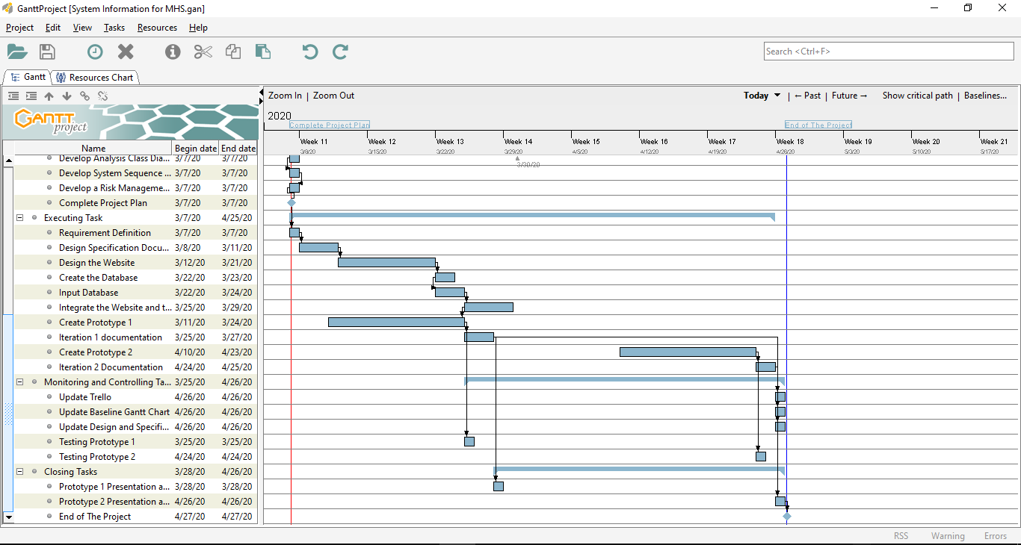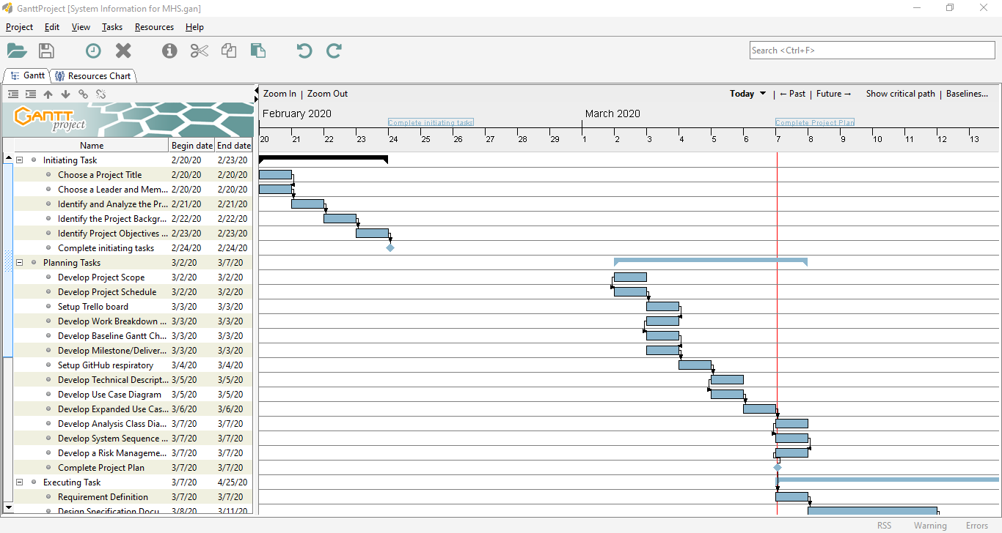**Technical Description of Proposed System**

* **Development Platform**
  + **Hardware**

1. Laptop

We use the laptop to make this project

1. Flash Drive

We use the flash drive to store and send the data

1. Printer

The function of this hardware for the project is to print out the project documentation.

* **Software**

1. Microsoft Word

We use this software to create and edit this project report

1. Microsoft Power Point

We make the presentation using this software

1. GanttProject

We use this software to make Gantt chart

1. Microsoft Visio

We use this software to make use case diagram, analysis class diagram, and sequential diagram

1. Adobe XD CC

We will use Adobe XD CC to design the website

1. Xampp

Xampp is a program to make a local server so we can make the website easier without buying hosting and domain

1. Browsers (Google Chrome and Mozilla Firefox)

We use the browser to test the website, setup Trello and GitHub.

1. Notepad++

We us Notepad++ to create and edit the script.

* **Demonstration Platform**
* Software Tools:

1. Web browser

To demonstrate this project, we use a web browser to run the prototype of the Information System for the Micro Housing System to check whether the function and design are working well. This can be tested on any web browser.

* Hardware:

1. Laptop

The prototype of the Information System for the Micro Housing System that we developed can be demonstrated by opening a web browser via a laptop.

**Risk Management Plan**

9

|  |  |  |  |  |  |  |  |  |  |  |  |
| --- | --- | --- | --- | --- | --- | --- | --- | --- | --- | --- | --- |
| **No** | **Rank** | **Risk** | **Description** | **Category** | **Root Cause** | **Triggers** | **Potential Response** | **Risk Owner** | **Probability** | **Impact** | **Status** |
| R5 | 1 | Lack of experience and understanding of working on projects based on applicable regulations. | Lack of understanding and experience of team members in working on projects based on applicable regulations so that it can have an impact on the project work process. | Process | Lack of understanding of the project being worked on. | Lack of time given to be able to understand the project being worked on. | Risk Mitigation | All members | High | High | Open |
| R2 | 2 | Delay or difficulty in developing a website for the project. | Lack of ability of team members or the time allotted in building a website. | Process | Lack of time given to work on the project. | Team members don't have the extraordinary ability to work on websites quickly. | Risk Mitigation | All members | High | High | Open |
| R4 | 3 | There could be damage to the system during the work process. | Possible damage to the system during the project work process. | System | Lack of competence of team members in building systems and the presence of external problems such as viruses. | Team members make mistakes in the process of working on the system. | Risk Mitigation | All members | Medium | High | Open |
| R1 | 4 | Lack of understanding of the software used in developing websites. | Due to lack of knowledge of the software used in developing projects, resulting in stunted application development. | People | Lack of knowledge about the software that will be used in the process of working on the website.  10 | Lack of time to learn about the software used in developing projects, results in problems when creating applications with new software. | Risk Mitigation | All members | Medium | Medium | Open |
| R3 | 5 | Lack of communication between team members raises many obstacles in the project work process. | All team members do not have adequate communication to discuss the continued development of the project. | People | Team members tend to be individualistic because they feel that they do not need to do much communication after the assignment of a prearranged task.  11  9 | Team members become individualists because they feel they only need to do the task for which they are responsible and do not want to know about the duties of other team members. | Risk Mitigation | All members | High | High | Open |

12

**BIT302**

**Software Engineering Assignment 1**

**Requirement Definition and Specification Document**



Project Title:

Information System for MHS

Prepared By:

Leader: I Kadek Bagus Paradhita Utama ([E1700866/bagusparadhita@gmail.com](mailto:E1700866/bagusparadhita@gmail.com))

Member: I Nengah Wahyudi Setiawan ([E1700868/nengahwahyudi90@gmail.com](mailto:E1700868/nengahwahyudi90@gmail.com))

**Table of Contents**

Functional and Non-functional Requirement2

Modelling Requirement3

Use Case Diagram3

High Level Use Case3

Expanded Use Case6

Analysis Class Diagram9

System Sequence Diagrams and Contracts10

Task Division16

References17

**Functional and Non-functional Requirements**

**Functional Requirement**

When the website is opened, several menus will be found, including the following:

* Set Up New Residence

Can be accessed by the Housing Officer to arrange information about new housing that is ready to be occupied, including residenceID, address, number of units available, size of each unit and monthly rent recorded.

* View Residences

Can be accessed by the Applicant to see information about the residence including residence ID, address, monthly rent, size of each unit and the number of units available.

* Submit Application

Can be accessed by the Applicant, where the applicant chooses where to reside, along with the month and year when the unit is needed.

* View Applications

Can be accessed by both the Housing Officer and the Applicant and shows different information for each user. If the user is a Housing Officer, a list of applications with the status "New" or "Waiting List" for Residence for which the Housing Officer is responsible is displayed, showing the Residence ID, number of units available and monthly rent, applicant's name, monthly income, month and year required. If the user is an Applicant, a list of applications that have been made by this Applicant is shown, showing the Residence ID, the number of units available and monthly rent, and the status of the application.

* Allocate Housing

Can be accessed by the Housing Officer to allocate housing by selecting residenceID, unitNo, fromDate and duration (12 months or 18 months) for the allocation.

**Non-functional Requirement**

* The appearance of the website is attractive and comfortable to look at.
* Website is easy to use.
* Can provide factual and accurate information.

**Modelling the requirements**

1. 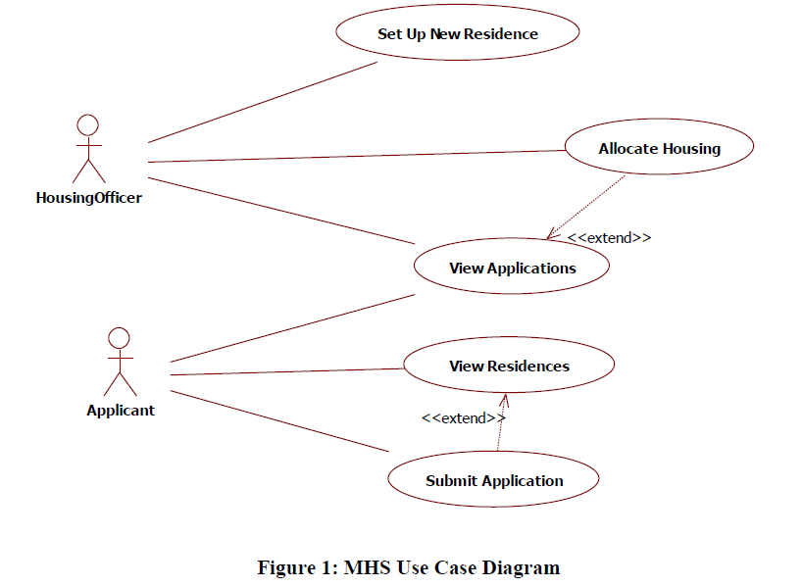**Use case diagram**

**High Level Use Case**

|  |  |
| --- | --- |
| Use Case | Set Up New Residence |
| Actors | Housing Officer |
| Description | The Housing Officer is responsible a particular Residence, and thus for setting up information about a new residence that is ready for occupation. The residenceID, address, number of units available, size of each unit and monthly rental is recorded. The Units are created according to the number of units entered. The availability of each unit is set to “available”. |

|  |  |
| --- | --- |
| Use Case | View Residences |
| Actors | Applicant |
| Description | The Applicant selects to view residences. For each residence, the residence ID, address, monthly rental, size of each unit and number of available units is shown. |

|  |  |
| --- | --- |
| Use Case | Submit Application |
| Actors | Applicant |
| Description | Before submitting an application for a unit, the Applicant will have to login or register by entering a username, password, fullname, email and monthly Income to create an account. (May need to submit copy of payslip to prove income).  The applicant selects the residence to submit an application for, and the month and year that the unit is required. An application is created for the applicant and the status is set to “New” |

|  |  |
| --- | --- |
| Use Case | View Applications |
| Actors | Applicant, Housing Officer |
| Description | If the user is a Housing Officer, a list of applications with status “New” or “Waitlist” for the Residence that the Housing Officer is responsible for is shown, showing the Residence ID, number of units available and monthly rental, applicant username, monthly income, month and year required.  If the user is an Applicant, a list of applications that have been made by this Applicant is shown, showing the Residence ID, number of units available and monthly rental, and application status. |

|  |  |
| --- | --- |
| Use Case | Allocate Housing |
| Actors | Housing Officer |
| Description | The Housing Officer selects an application to allocate housing by selecting the residenceID, unitNo, fromDate and duration (12 months or 18 months) for the allocation. The status of the application is set to “Approved”. The endDate of the allocation is automatically calculated. All other applications for the same Applicant are set to “Rejected”.  If the Applicant is not eligible for rental then all applications for that applicant are set to “Rejected”.  The Housing Officer may also set individual applications to “Waitlist”. |

1. **Expanded Use Cases**

|  |  |  |
| --- | --- | --- |
| **Use Case Name** | Set Up New Residence | |
| **Goal in Context** | To allow Housing officer to arrange information about new housing that is ready to occupied | |
| **Primary Actor**  **Secondary Actor** | Housing Officer  (none) | |
| **Typical Course of Events** | | |
| **Actor Actions** | | **System Response** |
| 1. This Use Case begins when the Housing Officer login to arrange information about new housing that was ready to be occupied | |  |
| 1. The Housing Officer records the number and information of each available unit | | 1. Units are made according to the number and information of units entered |
| 1. Housing Officers set the availability of each unit to “available” | | 1. The availability of each unit is set to “available” |
| **Alternative Course of Events** | | |
|  | | |

|  |  |  |
| --- | --- | --- |
| **Use Case Name** | View Residences | |
| **Goal in Context** | To allow the Applicant to see information about available housing | |
| **Primary Actor**  **Secondary Actor** | Applicant  (none) | |
| **Typical Course of Events** | | |
| **Actor Actions** | | **System Response** |
| 1. The use case begins when the Applicant choose “View Resident” to view information about available housing | | 1. The system displays the number and information of each available unit |
| **Alternative Course of Events** | | |
|  | | |

|  |  |  |
| --- | --- | --- |
| **Use Case Name** | Submit Application | |
| **Goal in Context** | To allow the Applicant to submit an application to choose a residence, along with the month and year when the unit is needed | |
| **Primary Actor**  **Secondary Actor** | Applicant  (none) | |
| **Typical Course of Events** | | |
| **Actor Actions** | | **System Response** |
| 1. This use case begins when the Applicant is login to submit an application for a unit | | 1. The system displays a list of available residences |
| 1. The applicant chooses a residence to submit the application, along with the month and year when the unit is needed | | 1. Application made for applicant and status is set to “New” |
| **Alternative Course of Events** | | |
| Line 1: If the Applicant does not have an account, the Applicant must first register to create an account | | |

|  |  |  |
| --- | --- | --- |
| **Use Case Name** | View Applications | |
| **Goal in Context** | Show the application to the Applicant | |
| **Primary Actor**  **Secondary Actor** | Housing Officer  Applicant | |
| **Typical Course of Events** | | |
| **Actor Actions** | | **System Response** |
| 1. This use case begins when a Housing Officer choose view application | | 1. System show list of applications with status “New” or “Waitlist” |
| 1. This use case begins when an Applicant choose view applications | | 1. System show list of applications that have been made by the Applicant |
| **Alternative Course of Events** | | |

|  |  |  |
| --- | --- | --- |
| **Use Case Name** | Allocate Housing | |
| **Goal in Context** | To allow Housing officer to select an application | |
| **Primary Actor**  **Secondary Actor** | Housing Officer  (none) | |
| **Typical Course of Events** | | |
| **Actor Actions** | | **System Response** |
| 1. This use case begins when the Housing Officer selects an application to allocate housing. Status of application is set to “Approved” and Housing Officer may set the individual applicant to “waitlist” | | 1. System automatically calculate the endDate of the allocation |
| **Alternative Course of Events** | | |
| **Line 2:** The other application that has same Applicant are set to “Rejected” and if the applicant is no eligible for rental then all applicants are set to “Rejected”. | | |

1. **Analysis Class Diagram**

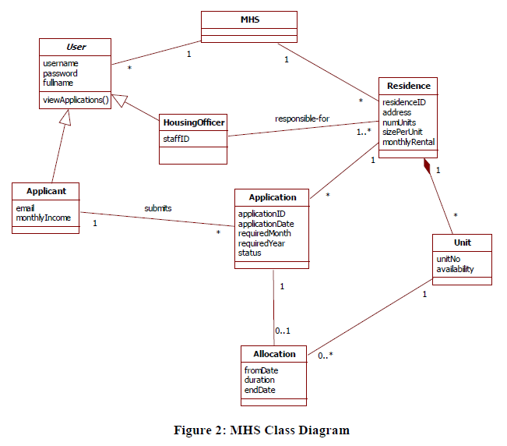

1. **System Sequence Diagrams and Contracts**

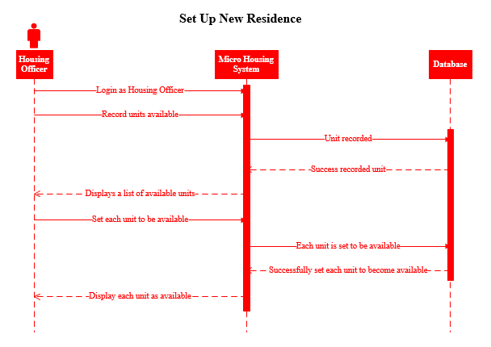

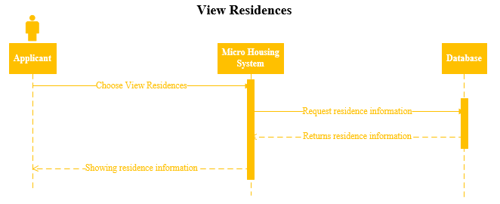

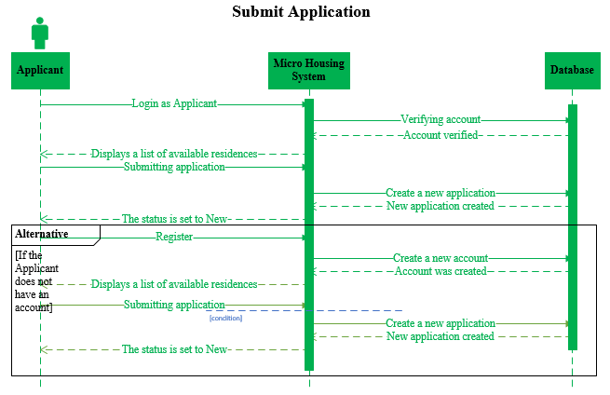

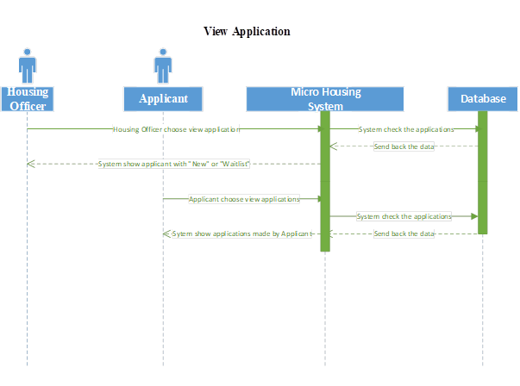



**Allocate Housing**

**Contracts**

**Set Up New Residence – Prepared by Bagus**

|  |  |  |  |
| --- | --- | --- | --- |
| Operation | Cross Reference | Precondition | Post condition |
| recordUnitsAvailable() | Use Case – Set Up New Residence | Housing Officer want to record the number and information of each available unit. | A list of available units is displayed. |
| setUnitAvailable() | Use Case – Set Up New Residence | Housing Officer want to set the availability of each unit to be "available". | The availability of each unit is displayed as "available". |

**View Residences – Prepared by Bagus**

|  |  |  |  |
| --- | --- | --- | --- |
| **Operation** | **Cross Reference** | **Precondition** | **Post condition** |
| chooseViewResidences() | Use Case – View Residences | Applicant wants to see information about available housing. | Residence information is displayed. |

**Submit Application – Prepared by Bagus**

|  |  |  |  |
| --- | --- | --- | --- |
| **Operation** | **Cross Reference** | **Precondition** | **Post condition** |
| applicantLogin() | Use Case – Submit Application | Applicant wants to submit an application for a unit. | Displays a list of available residences. |
| submittingApplication() | Use Case – Submit Application | Applicant wants to send the application after choosing a residence. | The status is set to "New". |
| register() | Use Case – Submit Application | Applicant wants to submit an application for a unit. | Displays a list of available residences. |

**View Application – prepared by Wahyudi**

|  |  |  |  |
| --- | --- | --- | --- |
| **Operation** | **Cross Reference** | **Precondition** | **Post condition** |
| chooseViewApplication() | Use Case – choose view application | Housing Officer want to view application | Displays application with status “New” and “Waitlist” |
| viewApplication() | Use Case – view application | Applicant want to view the application | Display application |

**Allocating Housing – prepared by Wahyudi**

|  |  |  |  |
| --- | --- | --- | --- |
| **Operation** | **Cross Reference** | **Precondition** | **Post condition** |
| allocateHousing() | Use Case – select Applicant to allocate Housing | Housing Officer allocate data and already selected | Showing the data to Housing Officer |
| allocateHousing() | Use Case – select Applicant to allocate Housing (alternative) | Housing Officer allocate data and already selected | The Housing Officer does not use the data because it is not eligible |

**Task Division**

|  |  |
| --- | --- |
| **Required Behaviour** | **Member’s Name** |
| The Set Up New Residence page is used by Housing Officers to arrange information about new housing that is ready to be occupied. | I Kadek Bagus Paradhita Utama |
| The View Residences page is used by the Applicant to view information about the residence available. | I Kadek Bagus Paradhita Utama |
| The Submit Application page is used by the Applicant, where the applicant chooses a residence, along with the month and year when the unit is needed. | I Kadek Bagus Paradhita Utama &  I Nengah Wahyudi Setiawan |
| The View Applications page is used by Housing Officers and Applicants and shows different information for each user. If the user is a Housing Officer, a list of applications with the status "New" or "Waiting List" for the Residence for which the Housing Officer is responsible is displayed. If the user is an Applicant, a list of applications made by this Applicant is indicated. | I Nengah Wahyudi Setiawan |
| The Housing Allocation page is used by Housing Officers to allocate housing. | I Nengah Wahyudi Setiawan |

**References**

Plastic bottle homes? Six ways to solve Hong Kong housing problem. (2018, April 20). Retrieved from <https://www.scmp.com/lifestyle/article/2142632/six-ways-solve-hong-kong-housing-problem-water-pipes-plastic-bottles>

Babulal, V., & Athirah, F. (2019, April 16). B40 youths can soon rent DBKL micro-homes for RM100 a month. Retrieved from <https://www.nst.com.my/news/nation/2019/04/480032/b40-youths-can-soon-rent-dbkl-micro-homes-rm100-month>

Plastic bottle homes? Six ways to solve Hong Kong housing problem. (2018, April 20). Retrieved from <https://www.scmp.com/lifestyle/article/2142632/six-ways-solve-hong-kong-housing-problem-water-pipes-plastic-bottles>

Babulal, V., & Athirah, F. (2019, April 16). B40 youths can soon rent DBKL micro-homes for RM100 a month. Retrieved from <https://www.nst.com.my/news/nation/2019/04/480032/b40-youths-can-soon-rent-dbkl-micro-homes-rm100-month>